# FUNCTIONS IN PYTHON

In programming we use functions too! A function is a mini program that runs and returns a value to your program.

There are a number of inbuilt functions in Python

## Inbuilt Functions

print() Function

* The print Function print() is used to display output to the user   
   The print() function can also be used with variables and a combination of text and variables
* The main task programs need to perform is gathering input from the user
* In Python we use the input() function to gather input from the user
* The program pauses and waits for user input.

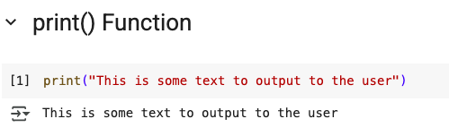

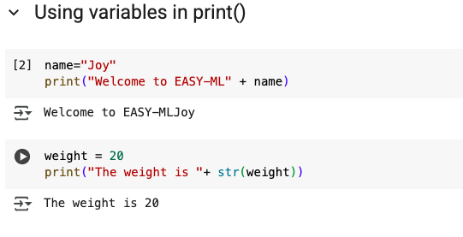

input() Function The main task programs need to perform is gathering input from the user

In Python we use the input() function to gather input from the user

The program pauses and waits for user input.

* By storing inputs in variables the program can prompt the user for multiple pieces of information.
* Simply use input statements in variable assignment statements.
* Input always returns a data type of **string**
* You have to convert the type, such as from **Str**ing to **Int**eger for example.
* input() always returns type **str** (string)

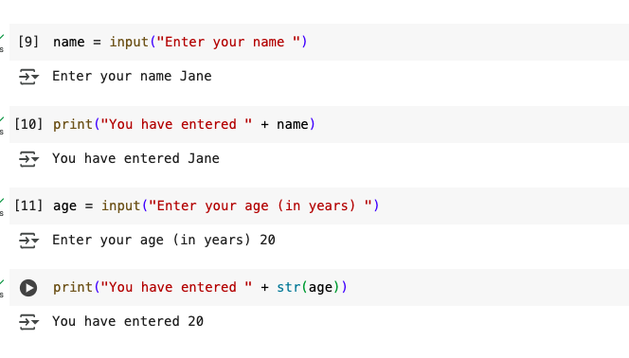

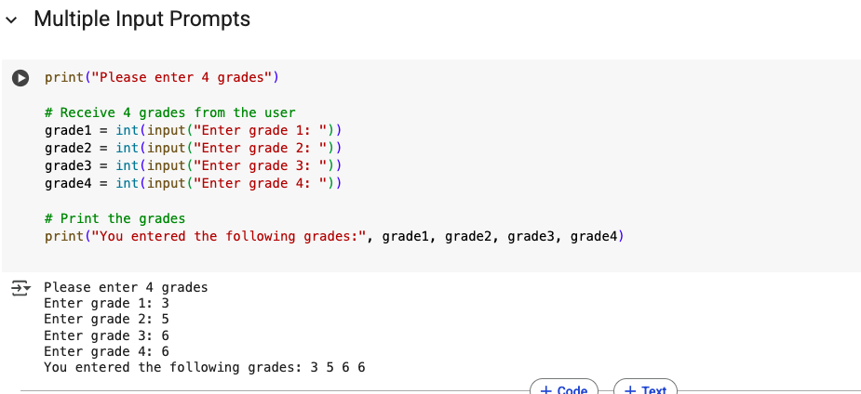

* Python assigns the data type automatically. But what if Python is using the data in a way we don't want?
* We must convert it using a **type conversion** where we **cast** the data type
* To cast a data type – use the specific Type keyword ( like int or str) in front of the variable or data

type() Function

Another built in Python function  
Returns the data type of the given data or variable 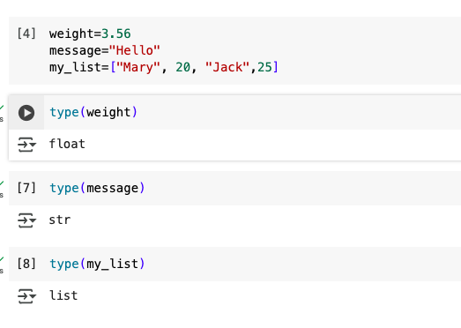

String Formatting

* There are method to format strings in Python. .capitalize() - capitalizes the first character of a string
* .lower() - all characters of a string are made lowercase .upper() - all characters of a string are made uppercase
* .swapcase() - all characters of a string are made to switch case
* upper becomes lower and vice versa
* .title() -each'word'separatedbyaspaceiscapitalized

## User Defined Functions

* User defined functions are those functions which are created by the user and are not inbuilt in Python.
* System functions are those inbuilt in Python e.g print(), input(), type() etc
* User defined functions are created by the user to do a specific tasks

User defined Functions structure

* Each user defined function must have the following:
* Starts with the keyword **def** Followed by the name of the function, with no
* spaces in between
* Followed by parenthesis **( )** then a colon **:** immediately after
* Inside the parenthesis, it can have one or more parameters. This is optional
* The body of the function
* The **return** keyword(also optional)
* Indentation must be adhered to

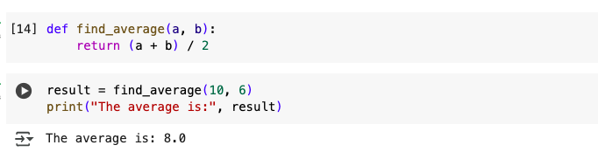

Arguments and Parameters

* After a function you might have noticed there are always **( )**
* Sometimes there is data inside the parenthesis sometimes not
* Anything passed in the ( ) is called an **argument**
* or a **parameter** when defining a function
* The input() function has 1 parameter: the message string to show the user
* input() takes 1 argument such as "what is your name? ", a string

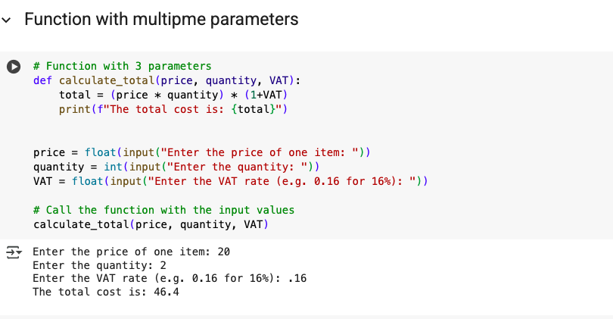

Simple Functions

* To create a function use the def keyword.
* Each line of the function under the definition MUST be indented. This is how Python knows it is part of the function.
* To call a function, type the name of the function like a built-in function.

function call: get_name()

Function with Return

* This simple function adds numbers, but **returns** a value to the function call
* In the add_numbers() function the user is asked for 2 numbers which are added together.
* The return keyword is used to send the result back to the num4 variable

Code Reuse

* We call the function more than once. This is the real power of a function
* So now the function is called twice and all 4 numbers are added together.
* But the additional code was only written once.

Functions With Parameters

Built-in functions like print() and type() take arguments.

User-defined functions can define parameters that will be accepteD

Multiple Parameters

* Separate each parameter with a comma.
* The number of parameters passed must exactly match
* the number in the def statement or Python will throw an
* error. Unless a default value is defined.